**1) Write a Query to fetch the Employee Name from the Employee Info table in uppercase and use the ALIAS name as Emp Name**

select upper(EmployeeName) As EmpName

from EmployeeInfo;

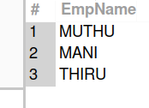

**2) Write a query to Count the number of employees working in the department 'HR'**

select count(*)

from EmployeeInfo

where Department='HR';

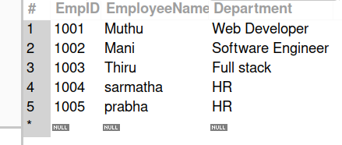

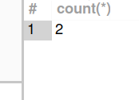

**3) write a query to update the product_name to 'Grapefruit' for all records whose product_name is "Apple".**

update Products

set Product_name='Grapefruit'

where Product_name='Apple';

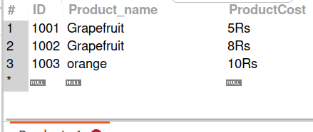

**4) Write a query to concatenate two-character strings?**

select *

from Student;

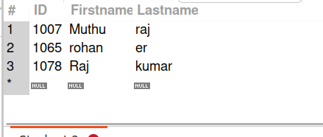

select concat(Firstname,Lastname)

from Student;

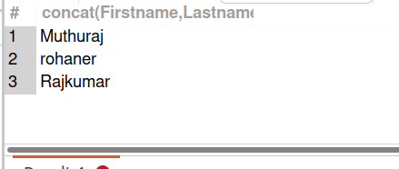

**5) Write a query to fetch all the records from the Employee table ordered by EmpName in descending order and Department in the ascending order**

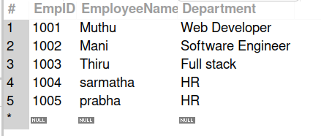

select *

from EmployeeInfo

order by EmployeeName desc;

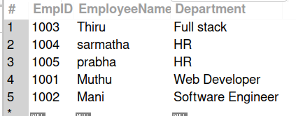

select *

from EmployeeInfo

order by Department asc;

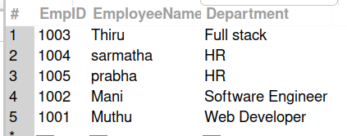

**6) From the following tables write a SQL query to find the salesperson and customer who reside in the same city. Return Salesman, customer Name and city**

select Salesmanname,Customername,Salesman.city

from Salesman,Customer

Where Salesman.city=Customer.city;

